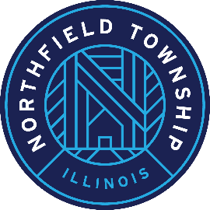

Township of Northfield

HUMAN SERVICES REVIEW COMMISSION MEETING AGENDA

Meeting of the Human Services Review Commission
Saturday, January 24, 2025 at 9 a.m.
2550 Waukegan Road, Suite 210
Glenview, IL 60025
Citizens are always welcome at Human Services Review Commission Meetings. The public
is invited to attend in person at the address listed above, or to listen or participate via "Google
Meet" using the details listed below.

Join with Google Meet:
Video call link: https://meet.google.com/fje-saog-xfx
Or dial: (US) +1 980-549-0368‬ PIN: 259 198 120‬#‬‬‬‬

Agenda:

- Welcome
- Approve minutes of the November 15, 2025 HSF Review Commission Meeting
- Review of process and funding formula
- Round robin recap of each agency’s application (1-minute synopsis per application)
- Discuss process next steps

- Reminder of February 10 Board of Trustees meeting

