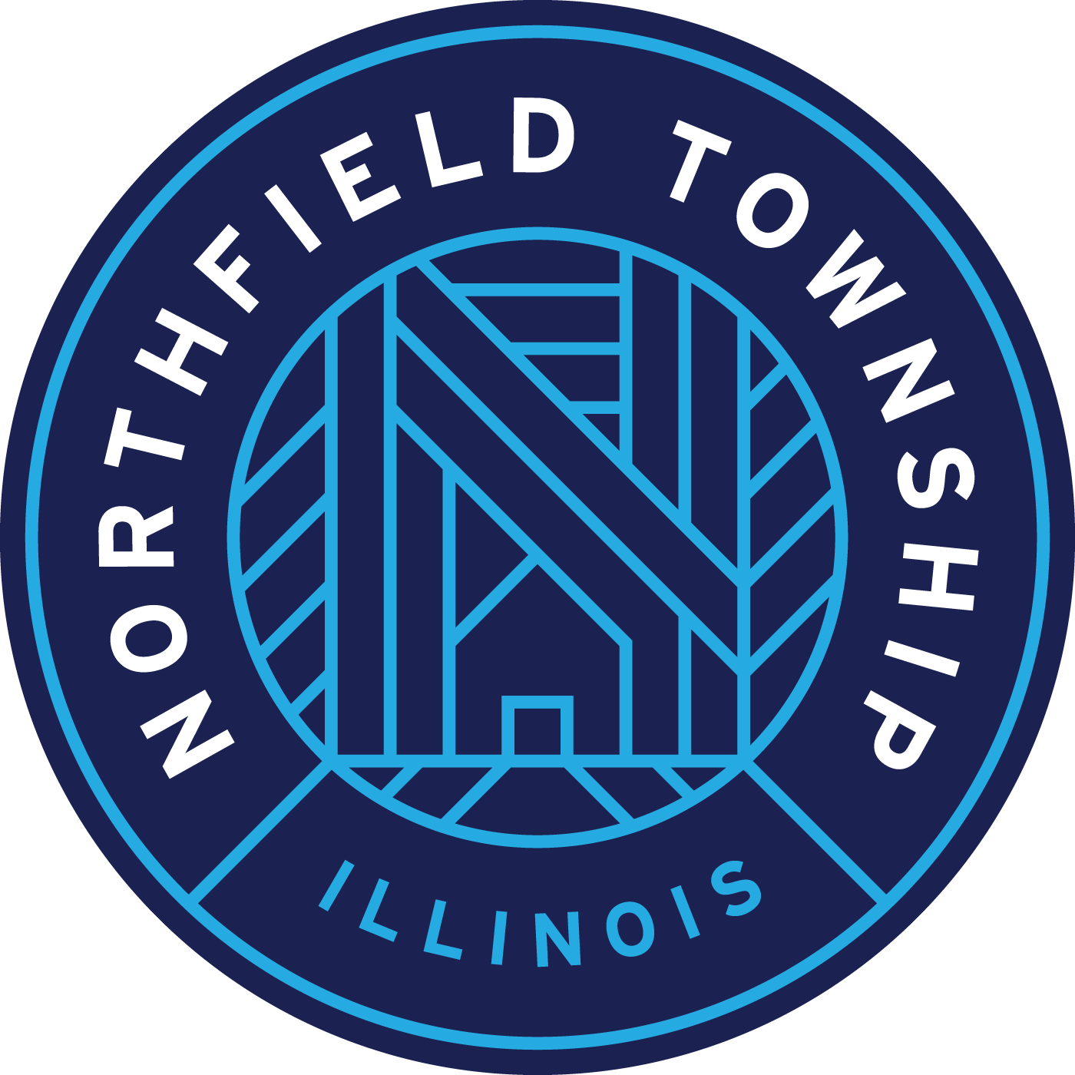

**Contact: Roxanne Dunn**

**Phone: 847-724-8300**

**Email: roxanne.dunn@northfieldtownship.com**

**Date: September 5, 2024**

**For Immediate Release:**

**2024 Property Tax Appeals Northfield Township**

The Cook County Assessor (CCA) is open for 2024 property tax appeals (property taxes paid in 2025)

for Northfield Township. The last day to file a 2024 appeal with the CCA is October 15, 2024:

[www.cookcountyassessor.com/online-appeals](http://www.cookcountyassessor.com/online-appeals).

Reasons you may choose to appeal your assessment this year: you did not appeal last year or you did

appeal, but did not get the reduction you hoped for, the assessed value of your property is not equitable

with properties similar to yours, your house is overvalued based on sales of similar homes, you recently

purchased your home or the characteristics of your property are not accurate, i.e. square footage,

number of rooms, age, etc. All properties in Northfield Township were reassessed in 2022 and will

next be reassessed in 2025.

Northfield Township Assessor Alida E. Nally, wants residents to know that as part of our taxpayer

services, Northfield Township can review your 2024 assessment and help file an appeal.

Residents can email Northfield Township for assistance, or make an in-person or telephone

appointment to review their assessment: propertytaxhelp@northfieldtownship.com,

<https://tinyurl.com/propertytaxassist2024>, or call (847)724-8300 x 2.

-END-