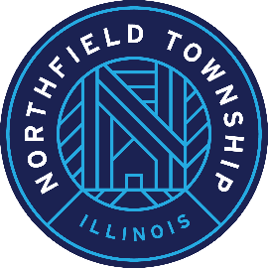

Township of Northfield

HUMAN SERVICES REVIEW COMMISSION MEETING AGENDA

Meeting of the Human Services Review Commission
Saturday, January 27, 2024 at 9 a.m.
2550 Waukegan Road, Suite 100
Glenview, IL 60025
Citizens are always welcome at Human Services Review Commission Meetings. The public
is invited to attend in person at the address listed above, or to listen or participate via "Google
Meet" using the details listed below.

Join with Google Meet:
https://meet.google.com/qfx-ansz-wws

Join by phone:
+1 574-279-9039‬ PIN: 703 858 758‬#‬‬‬‬

Agenda:

- Welcome
- Approve minutes of the November 04, 2023 HSF Review Commission Meeting
- Review of process, funding amounts recommended, & total funds to be distributed
- Determine each agency funding recommendation to be submitted to the Board of Trustees for review & approval

- Reminder of February 13 Board of Trustees meeting

- Questions or concerns

