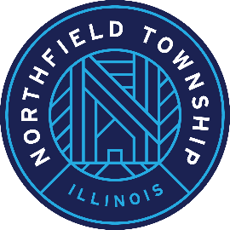

***Township of Northfield***

**HUMAN SERVICES REVIEW COMMISSION MEETING AGENDA**

**Meeting of the Human Services Review Commission**

Saturday, November 4, 2023 at 11 a.m.

2550 Waukegan Road, Suite 100

Glenview, IL 60025

Citizens are always welcome at Human Services Review Commission Meetings. The public

is invited to attend in person at the address listed above, or to listen or participate via "Google

Meet" using the details listed below.

**Join with Google Meet:**

<https://meet.google.com/scs-pnfi-wqs>

**Join by phone:**

+1 929-777-5487‬ PIN:

**Agenda:**

1. **Introductions**
2. **Overview of the HSF process for new Commission members**
3. **Commission elects a chair**
4. **Discuss agencies assigned to each member for review**
5. **Questions or concerns?**